Lesson Plans for Art I and Art II
9/2/14-9/5/14
Lessons are Based on Day 1 and Day 2 since students are only seen twice in ABC days. Day 1 is for their first class (either A or B) Day 2 is for their second class (either B or C)
Day 1 (9/2 or 9/3)
Show student the piece of art The Return of Odysseus by Romare Bearden- American artist 1977
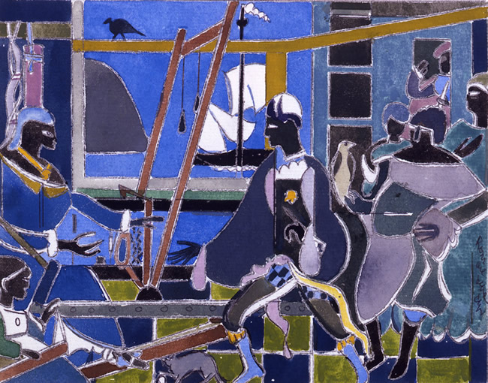

The student will take a few moments to evaluate the work and look at what is going on.
Prompt the student to write about what they see, think, and wonder about the work:
I see: What do you see? | I think: What do you think about that? | I wonder: What does it make you wonder?
Ask students to create a chart like this on their own paper.

After they have taken some time to evaluate the work, discuss it as a group, talk about the differences in opinions. The purpose of this activity is for making careful observations and thoughtful interpretations.

After this activity, show the student the piece of art The Migration by William Gropper 1932.
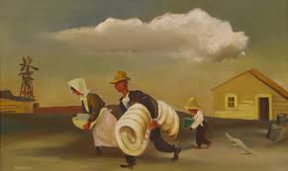

Similar to the last activity, ask the student to write about the following on their own paper:
- What’s going on (happening) in this picture?
- What makes you say that? What evidence is there?

Once they have finished, discuss the responses as a group (or one on one)to see what differences you saw.

Day 2 (9/3 or 9/4)
Prompt for student activity: create a comic strip to tell about you and your life. It could be about a specific event that has happened to you or even something totally made up and over exaggerated. You can use real people who are in your life, or make up characters to represent them. Images can be cartoonlike and non-realistic, people, animals, even aliens. Include speech or thought bubbles, action signs, and whatever else you need to tell your story. It should use a minimum of 4 blocks, but feel free to use more. This should be fully colored and completed to your best abilities.

Friday 9/5
Show students the art work Nighthawks by Edward Hopper 1942.
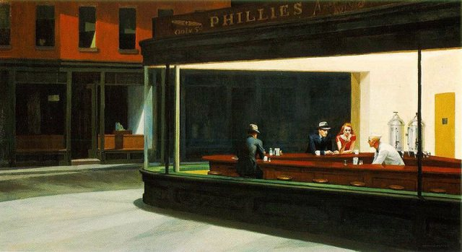
Prompt student to complete claim/support/question on their own paper
- Claim: Make a claim about the artwork or topic. (claim= an explanation or an interpretation of some aspect of the artwork)
- Support: Identify support for your claim. (support= things you see, feel and know that support your claim)
- Question: Ask a question related to your claim. (Question= what’s left hanging? What isn’t explained, What new reasons does your claim raise?)
Discuss together
Next show the students A Sunday on La Grande Jatte by Seurat 1884.
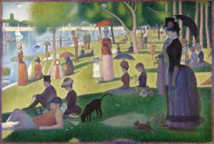
Ask students to answer Beginning/Middle/End questions on their own paper.
- Beginning: If this work is the Beginning of a story, what might the beginning of the story be? What might happen next?
- Middle: If this work is the Middle of a story, what might have happened before? What might be about to happen?
- End: If this work is the End of a story, what might the story be?
After answering, allow for discussion to see differences in opinions.

