Triangles ABC and PQR pictured below are congruent:
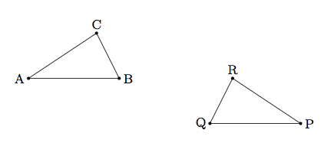
- Show the congruence using rigid motions of the plane.
- Can the congruence be shown with a single translation, rotation, or reflection? Explain.
- Is it possible to show the congruence using only translations? Explain.
- Is it possible to show the congruence using only rotations? Explain.
- Is it possible to show the congruence using only reflections? Explain.

Below is triangle ABC and a rotated image triangle DEF.
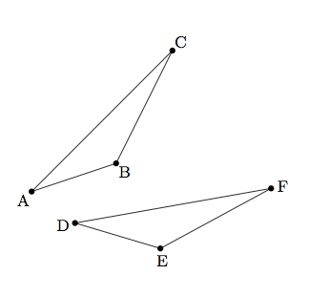
- Explain how to identify the center of rotation.
- Once you have found the center, how do you find the angle of rotation?

The triangle in the upper left of the figure below has been reflected across a line into the triangle in the lower right of the figure. Use a straightedge and compass to construct the line across which the triangle was reflected.
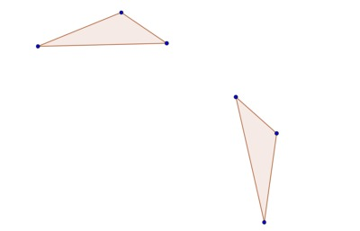

Below is a picture of a regular octagon, which we denote by O, and two lines denoted ℓ and m, each containing one side of the octagon:
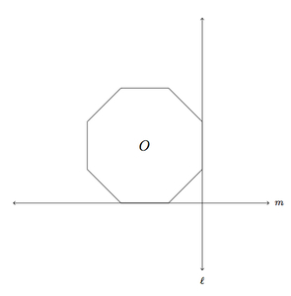
- Draw rℓ(O), the reflection of the octagon about ℓ.
- Draw rm(O) and rm(rℓ(O)), the reflections of the two octagons from part (a) about line m.
- Show that the quadrilateral enclosed by the four octagons O, rℓ(O), rm(O), and rm(rℓ(O)) found in parts (a) and (b) is a square.

