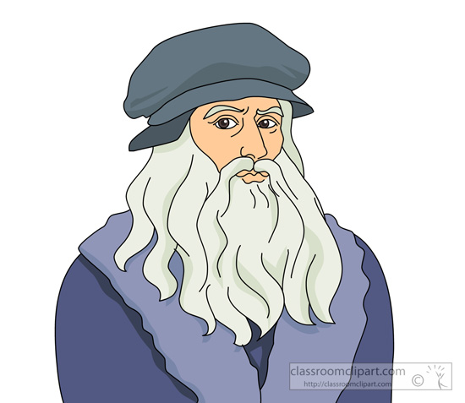

Hello. My name is Leonardo da Vinci. I am 50 years old. I come from Italy but I live in France. I like to paint.

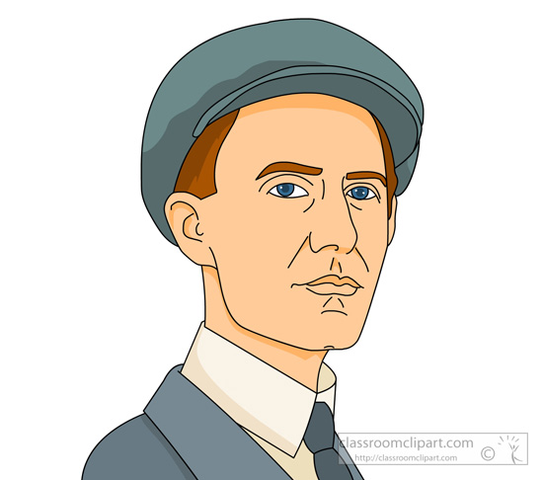

Hi. My name is Wilbur Wright. My brother's name is Orville. I am 43 years old. I come from Indiana but I live in Ohio now. I like to fly.

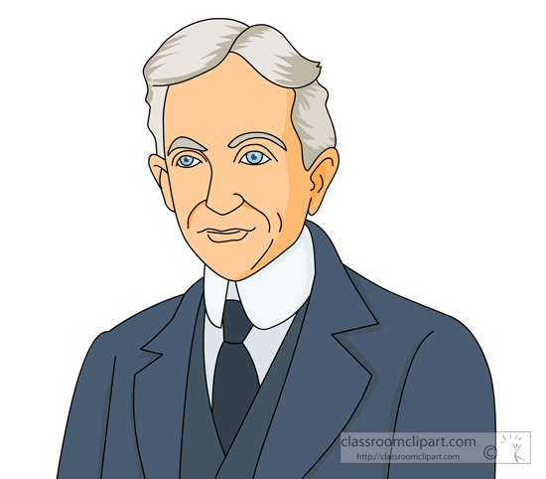

Hello. My name is Henry Ford. I live in Michigan and am 67 years old. I prefer driving cars *than* (als) riding bikes.

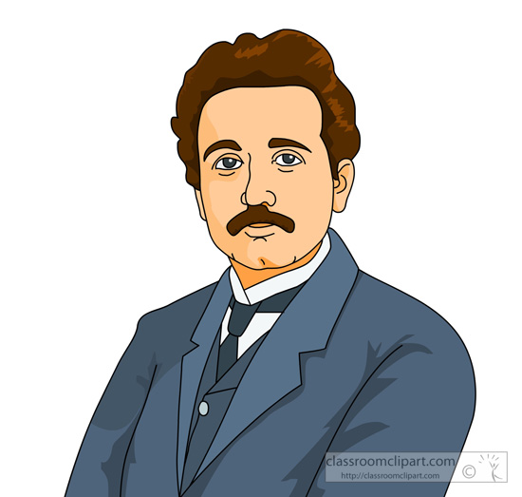

Hi. My name is Albert Einstein. I am from Germany but I live in New Jersey. I am 65 years old. Physics is my favorite subject. I have five children.

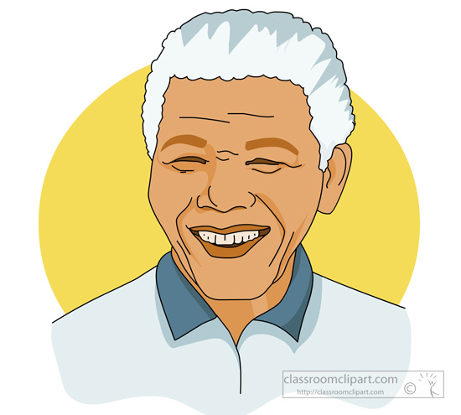

Good evening. I am Nelson Mandela. I live in South Africa. I am 94 years old. Politics is my favorite subject.

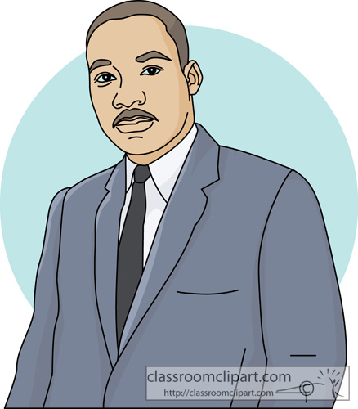

Good afternoon. My name is Martin Luther King, Jr. I come from Georgia and am 30 years old. I am very religious and I have *a dream* (ein Traum).



Greetings. My name is Charlemagne the Great. I live in Aachen, Germany. I am 48 years old and am *a king* (ein König).

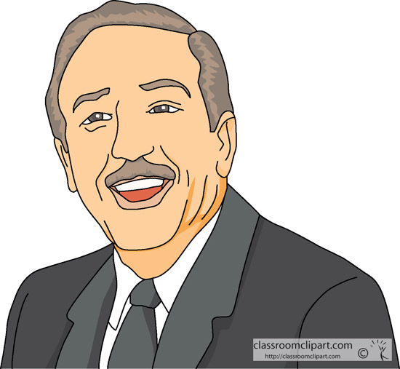

Hi! I am Walt Disney. I live in California and am 55 years old. I really enjoy watching movies.

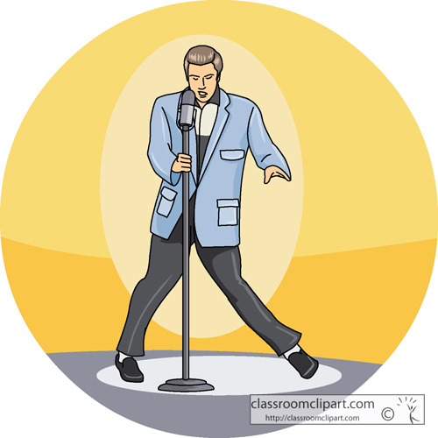

Hello. My name is Elvis Presley. I am 35 years old and live in Tennessee. I have one daughter. I like to sing and listen to music.

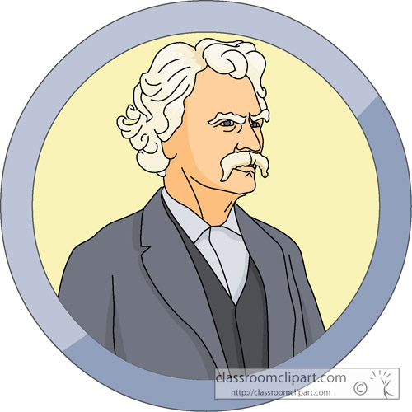

Good evening. My name is Mark Twain. I am 42 years old. I come from Missouri and live in Connecticut. I like to read and write books.

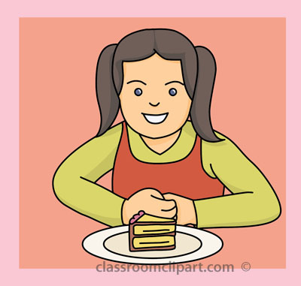

Hi. My name is Greta. I am 8 years old and I live in Germany. I like to eat cake. I am happy.



Good morning. My name is Asuka and I live in Japan. I am 37 years old. I like to cook and dance.



Morning! My name is Imke and I am 12 years old. I live in Austria and I like to play soccer and volleyball. I also like to go to school. My favorite subject is Math.



Hello. My name is Klaus. I live in Germany and I am 15 years old. I like to play video games and cards. I like to ride my bike. I ride my bike to school.



Hello. My name is Hans and I am 32 years old. I live in Switzerland. I like to *travel* (reisen).



Hello. My name is Julia and I am a waitress. I am 25 years old and I live in Germany. I like to eat and wear pretty dresses.



My name is Jerry. I am 21 years old and I come from America. I like to sleep. I am really tired and I want to go to bed. Good night.



My name is Justin and I am 32 years old. I am an American and baseball is my favorite sport.



Hi. My name is Brigitte and I am 23 years old. I live in Germany. I like to watch TV and my favorite subject is *computer technology* (Informatik).



Good afternoon. My name is Jutta and I am 43 years old. I live in France. My favorite subject is *law* (Jura).



Hi! I am Claudia. I am 19 years old and I live in Berlin. I like to go *to the* *disco* (ins Disko) and dance. Red is my favorite color.



Hello. My name is Helga and I am German. I am a grandmother and have 5 grandchildren. I like to cook and bake. I wear glasses and am happy.



Hello. My name is Steffi. I am 16 years old and I do yoga (Yoga) every day. I am very happy. My favorite colors are pink and blue.



Hello. My name is Tara and I am from France. I am 18 years old and I drive to school. I like to go shopping and my favorite color is green.



Good evening. My name is Olga and I am 52 years old. I live in Austria and I like to sing.



Hello. Our names are Anne and Eva and we are *twins* (Zwillinge). We are 24 years old and we live in Munich. We like to hike and read books.



Good evening. My name is Sara and I come from Germany. I am 36 years old and I am a teacher. I *teach* (unterrichten) English and social studies.



Hi! My name is Tara and I am from Turkey. I am 8 years old and come to school by bus. My favorite subject is art and my favorite color is pink.